

FALCON’s Response to Festo
for Supply Of Conveyor Automation – 2K
Option – 5A
September 30, 2024

Kind Attention –
M/s Festo

Offer Ref: F24-00322 Option 5A ; Date: 30-09-2024

Subject – Techno -Commercial Offer of Conveyor Automation System 2K PPH

We are pleased to submit our Techno-Commercial Offer in response to your RFP.
As you will note, we have done an in-depth data analysis and evaluated various solution options best suited for your requirements, along with the information collected during the meetings and discussions with you, we have put together a detailed technical proposal laid out in various sections and sequenced to enable you to understand our proposed solution and to re-enforce our commitment to being your partner in this strategic initiative.
In subsequent sections, we have highlighted the capabilities and experiences of Falcon Autotech with sections on our Intra-logistics Automation Technologies and references.
To conclude, I would like to add my personal commitment on behalf of Falcon Autotech. As we move through the RFP process, please do not hesitate to contact me and my team. We will be pleased to assist you with any further information or clarifications that you might have.
Best Regards,
Sandeep Bansal
Chief Business Officer

Response to RFP for
Conveyor Automation 2K PPH Throughput
(Kolkata)

Proposal Reference – F24-00322 – Option 5A

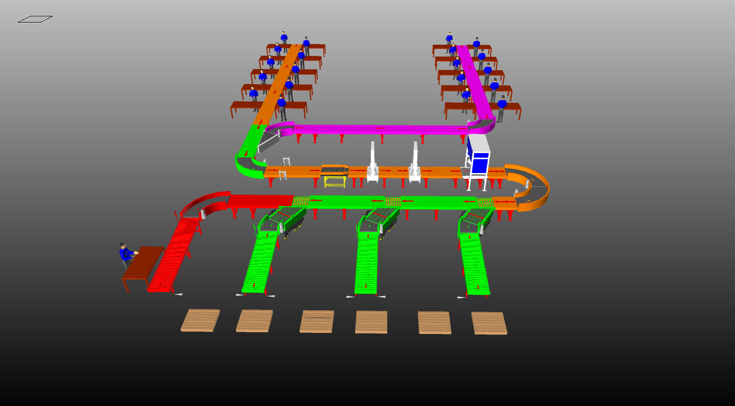

Table of Contents
1. Glossary 6
2. Executive Summary 7
3. Handled Parcel Spectrumions Minimum Maximum 8
3.1 Product size Conveyable on the entire system. 8
3.2 Parcels to be loaded on Conveyor/Sorter shall have the following characteristics: 8
3.3 Parcel not loadable on the system 9
3.4 Types of Products 9
4. Proposed System Description 10
4.1 Objective 10
4.2 Summary of the System 10
4.3 Main benefits of the proposed solution 11
5. Layout View 11
6. Proposed System Capacity 12
6.1 System Capacity at various areas 12
7. System description 12
7.1 Infeed Lines and Loop 12
7.2 Automatic Strapping System 13
7.3 Outbound Sorter 13
8. System Components 14
8.1 Powered Roller Conveyor 14
8.2 Accumulation Conveyor 15
8.3 PVC Belt Conveyor 16
8.4 Powered Roller Turns & Merges 17
8.5 Centre Aligner 17
8.6 Side Barcode Scanners 18
8.7 Strapping Machine 19
8.8 Swivel Wheel Sorting Unit – Falcon 19
9. Proposed System Technical Details/BOM 20
9.1 Mechanical equipment 20
9.2 Electrical Equipment 21
9.3 Control System 21
10. High Availability Server Specifications 22
11. Falcon’s WCS CONTROLIT 23
12. Key Component Makes 24
13. Safety 24
13.1 Push Buttons 24
14. Program Organisation 25
14.1 Program Management 25
15. Commercial Terms 25
15.1 Price Sheet 25
15.2 Payment Terms 26
16. Warranty Period 27
17. Exclusions 28

Glossary
S. No. | Term | Description
1 | RFQ | Request For Quote
2 | PPH | Parcels Per Hour
3 | AC | Alternating Current
4 | DC | Direct Current
5 | PLC | Programmable Logic Controller
6 | IT | Information Technology
7 | BOQ | Bill Of Quantity
8 | I/O | Input/ Output
9 | PDP | Power Distribution Panel
10 | PC | Personal Computer
11 | UPS | Uninterrupted Power Supply
12 | SWEDI | Swivel Wheel Divert

Executive Summary
Falcon Autotech is pleased to confirm its great interest in responding to this Festo RFQ of Conveyor Automation System. Our team has been working closely with the relevant stakeholders, with a clear commitment to listening, understanding your needs, and ensuring this project's success.
Following the same objective for the Festo Conveyor automation system, we are happy to offer a compliant solution meeting all technical and operational requirements at competitive price, delivering key results.

Our solution is based on the following key characteristics:

Conveyor Automation System 2K PPH:-

• Two Dedicated lines for loading final order carton (1st presently & 2nd in future).

• Dedicated Strapping Machine for Big box strapping in line to the main Highway line.

• Main Highway line Is integrated with Top Barcode Scanner.

• SWEDI Diverters are placed to Divert the carton at final destinations.

Handled Parcel Spectrumions Minimum Maximum

Product size Conveyable on the entire system.

Max Length | mm | 810
Max Width | mm | 665
Max Height | mm | 420
Max Weight | Kg | 40
Min length | mm | 210
Min Width | mm | 145
Min Height | mm | 75
Min Weight | Kg | 1

Parcels to be loaded on Conveyor/Sorter shall have the following characteristics:

- Centre of Gravity of items must not move during conveyance or sorting.
- Item must not have magnetic content; otherwise behaviour of parcel cannot be guaranteed.
- Liquid or fragile material, to avoid breaking, spillage or leakage, such as wine bottles, metal cans of paint are designated as non- conveyable items.
- Parcels shall be perfectly and safely packaged: protrusion or open surfaces are not allowed.
- Plastic ropes shall be perfectly adherent to the surface of the package.
- All items with the risk of being damaged during the transport on an automatic conveying/sorting system or damaging the system. They must be robust enough to avoid disintegration of container material and loose of contents in the conveying/sorting process.
- Item packaging shall have enough grip to be handled on the belts during the acceleration and
referencing phases.
- Items shall not have slippery surfaces and must be able to withstand acceleration of the items on the belt during the start-stop phases (accelerations up to 0.5 g shall be assured without any sliding or tumbling of the items on the belt conveyor).
- The parcels must have at least one flat and regular surface providing enough stability during conveyance.
- All shapes are permitted except spherical, cylindrical, or alike unstable items & shapes.
- All usual packaging materials are permitted (including paper, carton, plastics, plastic foil, rope, tape, textile, and wood)

Parcel not loadable on the system
All products that are not within the range as described here, are considered non- conveyable products, and must be taken out of the main sorter flow by the operators.

- Unstable items with a risk to roll or tumble on the sorting system, such as spherical or cylindrical items
- Items that have a spherical or cylindrical shape.
- Items that are packed in material that can damage the conveyors or the sorter.
- Items that have sharp points (e.g. Nails) or sharp edges, that can damage the conveyors or the sorter.
- Fragile parcels with contents not sufficiently secured
- Items that have been classified as dangerous are designated.
- Wet items are designated.
- Items with anti-slip treatment.
- Items with protruding parts.
- Items with sharp edges.
- Inadequately packed items that could be damaged during automatic transportation.
- Electrostatically loaded items.
- Loose parts on loads and load carriers, such as adhesive tape, stickers, slips of paper, straps, wrap foil etc. are designated as non- conveyable items.

Types of Products
Parcel Type | Description
Cartons | Types of Carton  Min: L-210 X W-145 X H-75 MM  Max: L-810 X W-665 X H-420 MM

Proposed System Description

Objective
The purpose of this proposal is to present the design, manufacturing, installation, commissioning, testing and acceptance testing of the complete automation system to handle Cartons as per specifications shared by Festo.
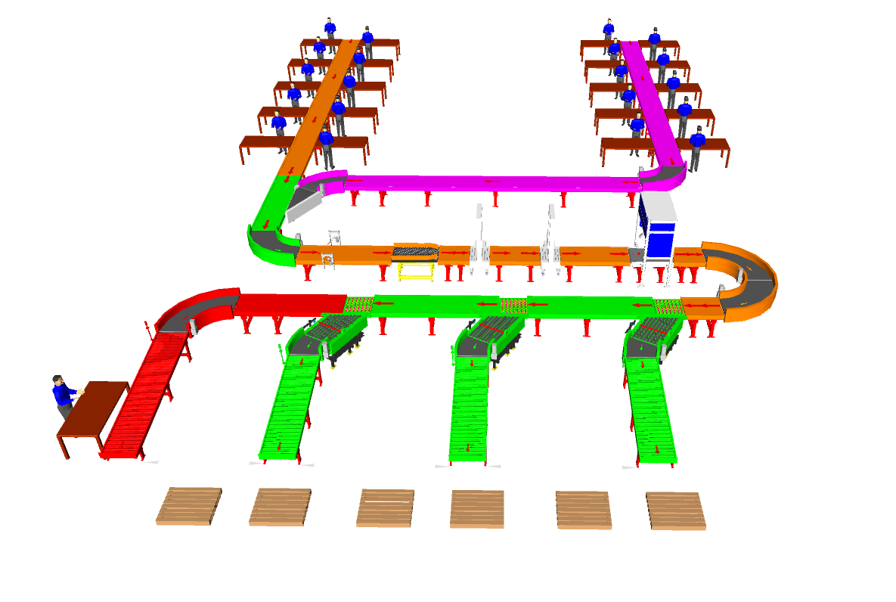

Summary of the System
- Infeed: SKU Cartons are fed into the system through Infeed lines running throughout the packing table area.

- Carton Strapping: All of the boxes will be scanned via side barcode scanner & Only big boxes will get auto strapped.

- Outbound Sorter: Top barcode scanner scans the barcode data present on the cartons & Cartons are sorted Beat wise through SWEDI Diverter into three main aisles.

- Provision for rejection line for inspection & rework is given separately.

- Distance b/w Scanner and Divert units is kept considering communication through PLC. (Stackbox to ensure WCS to have required data on regular basis)
\

Main benefits of the proposed solution
The proposed solution has the following advantages:
- High operational throughput
- Maximized sorting capacity throughout at dispatch sorter to meet the requirement.
- Low occupancy of floor space in the building
- FALCON’s system can adapt with changing business requirements by adjusting its speed to match the operational throughput requirement, thereby leading to Power Savings and reduced system Wear & Tear

Layout View

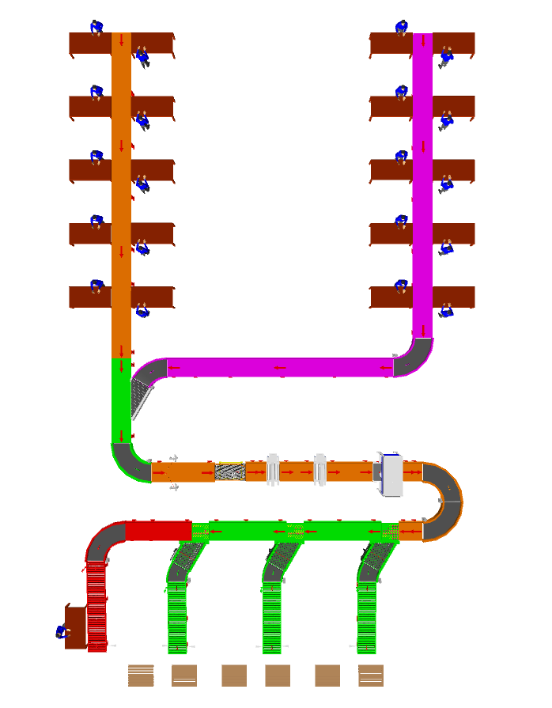
1
1

2
2

5
6
4
3
Legend
1 – Packing Table
2 – Infeed loading line
3 – Side Barcode Scanner
4 – Centre Aligner
5 – Auto Strapping machine
6 – Scanning Tunnel & Weighing
7 – Main Outbound Sorter
8 – Rejection Line

8
7

Proposed System Capacity

System Capacity at various areas
Activity | Cartons per hour
Infeed Lines and Loop | 1000
Strapping Machine | 1000
Outbound Sorter | 1000

System description

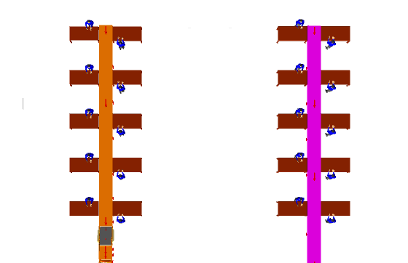
Infeed Lines and Loop

2
1
1
2

Legend
1 – Packing Tables
2 – Infeed Line

Automatic Strapping System
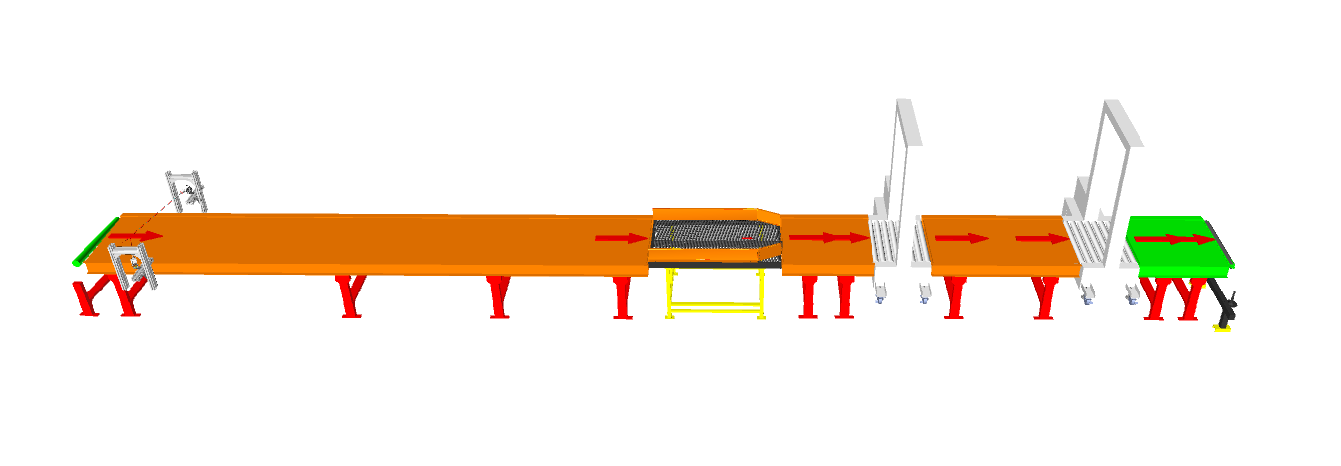
3
3
2
1

Legend
1 – Side Barcode Scanner
2 – Centre Aligner
3 – Strapping Machine

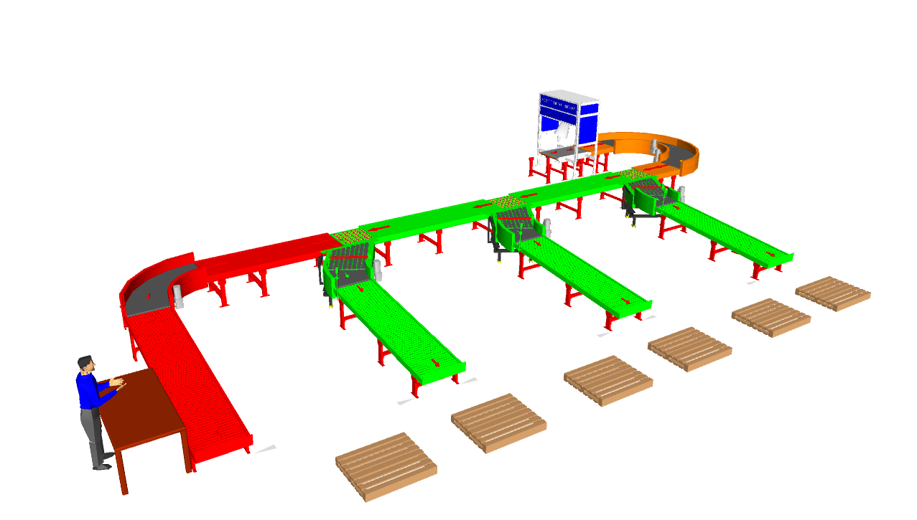
Outbound Sorter
1
2
2
3
2

4

Legend
1 – Barcode Scanner & Weighing Conveyor
2 – SWEDI Diverter
3 – Main Sorting Highway
4 – Rejection Line

System Components

Powered Roller Conveyor
Falcon’s Roller conveyors are highly energy efficient and require negligible maintenance leading to very minimal Operating costs and thus lower cost of ownership.
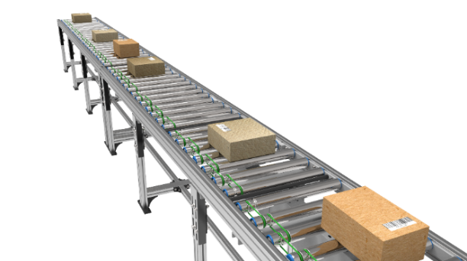
Some Salient Features of Falcon’s roller conveyor:
- Low Noise
- Maximum uptime.
- Minimal maintenance
- High safety standards.
- Fastest ROI
- Comes with MS frame.

Specification | UOM | Remark
Manufacturer Name | Name | Falcon Autotech
Material of Roller | Type | MS Rollers with Zinc Plating
Overall Width | mm | 800
Conveyor Height | mm | Variable as per design shared
Drive Power Rating | Watt | 40
Type of Motor | Type | DC Rollers (MDR)
Ingress Protection | Type | IP 54
Type of Drive System | Type | Poly V Belt Drive
Insulation Class | Type | Yes
Conveyor Speed | m/s | Variable speed to meet TPH requirements
Load capacity/unit length of Conveyor | kg/m | 50
Roller Span | mm | Variable
Roller Diameter | mm | 50
Pitch of Rollers | mm | 75/100
Type of Mounts | Type | Fixed Heights Legs with required Grouting Provisions

Accumulation Conveyor
Falcon’s Accumulation conveyors are highly energy efficient and require negligible maintenance leading to very minimal Operating costs and thus lower cost of ownership.
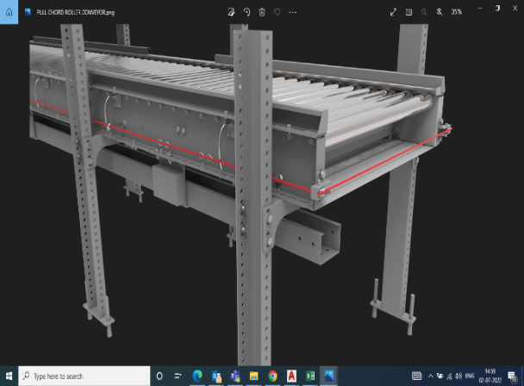
Some Salient Features of Falcon’s accumulation conveyor:
- Low Noise
- Maximum uptime.
- High safety standards.
- Fastest ROI
- Comes with MS frame.

Specification | UOM | Remark
Manufacturer Name | Name | Falcon Autotech
Material of Roller | Type | MS Rollers with Zinc Plating
Overall Width | Mm | 800
Conveyor Height | Mm | As per Layout requirement
Drive Power Rating | Watt | 40
Type of Motor | Type | DC Rollers (MDR)
Ingress Protection | Type | IP 54
Type of Drive System | Type | Round/Poly V Belt Drive
Insulation Class | Type | Yes
Conveyor Speed | m/s | Variable speed to meet TPH requirements
Load capacity per unit length of Conveyor | kg/m | 50
Roller Span | Mm | Approx. 600
Roller Diameter | Mm | Approx. 50
Pitch of Rollers | Mm | 75
Zone Length | Mm | 825
Type of Mounts | Type | Fixed Heights Legs with Grouting Provisions
Type of Guides | Type | Steel guides at 50mm height basis the position of conveyor on both sides from Conveyor Belt Surface.

PVC Belt Conveyor
Falcon’s Belt Conveyors are modular & robust in design. MS profile is used to build conveyor frame.
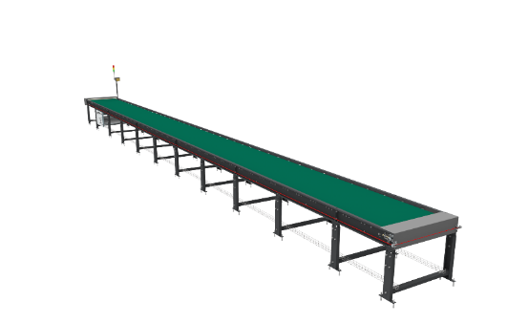
Some Salient Features of Falcon’s Belt conveyor:
- Low Noise
- Maximum uptime.
- Minimal maintenance
- High safety standards.
- Fastest ROI.

Specification | UOM | Remark
Manufacturer Name | Name | Falcon Autotech
Material of Roller | Type | MS Rollers with Zinc Plating
MOC of Belt | Type | PVC
Belt Thickness | mm | 3
Belt Finish | Type | Matt Finish
Belt width | mm | 800
Belt Joint Type | Type | Vulcanized, Endless Belts
Belt Make/Model No. | Make | FORBO/DERCO
Chassis | mm | MS, 3mm Thick, Powder Coated-75 Microns
Idler Roller Pitch on running side (Top) | mm | 480
Idler Roller Pitch on return side (Bottom) | mm | 1200
Idler Roller Specs | Spec | Dia.50.8, shaft-12 mm, bearing-6301
End Rollers | Spec | Dia 81.2 x 2.85 Thick, 30mm Shaft Dia, & Bearing Size-UCFH206D1, MOC-EN9, Zinc Plated -25 microns
Drive Rollers | Spec | OUTER Dia 178 PIPE Dia 168x5 Thick, 40mm Shaft Dia, & Bearing Size-UCF208D1, MOC(SHAFT)-EN9, NEOPRENE RUBBER COATING
Tensioning Rollers | Spec | Dia 81.2 x 2.85 Thick, 25mm Shaft Dia, & Bearing Size-UCT205D1, MOC-MS, Zinc Plated -25 microns
Type of Drive | Type | Rubberized
Angle of wrap/Contact - Belt with Drive pulley | Deg | >180 deg
Motor Shaft | MOC | EN9 Shaft material,
Load capacity per unit length of Conveyor | kg/m | 50
Drive Power Rating | kW | Motor Rating depends on Length of the Conveyor
Type of Motor | Type | AC Geared Motor
Ingress Protection | Type | IP 55
Type of Drive System | Type | Direct Shaft Mounted Motor/ Flange Mounted
Type of Drive | Type | Chain drive/Torque Arm type
Gear Motor | make | Sew/Nord
Drive | make | Lenze/Siemens/Omron/Allen Bradly
Insulation Class | Type | Yes
Conveyor Speed | m/s | Variable speed to meet TPH requirements
Type of Mounts | Type | Fixed Heights Legs with Grouting Provisions

Powered Roller Turns & Merges
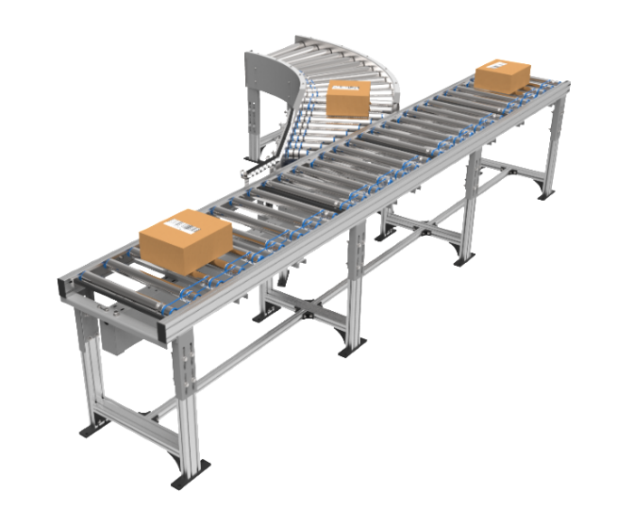
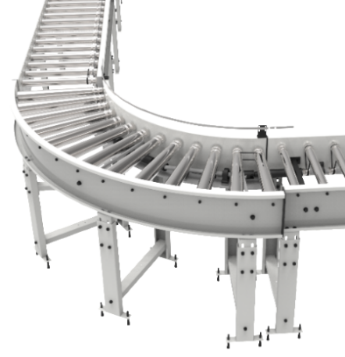

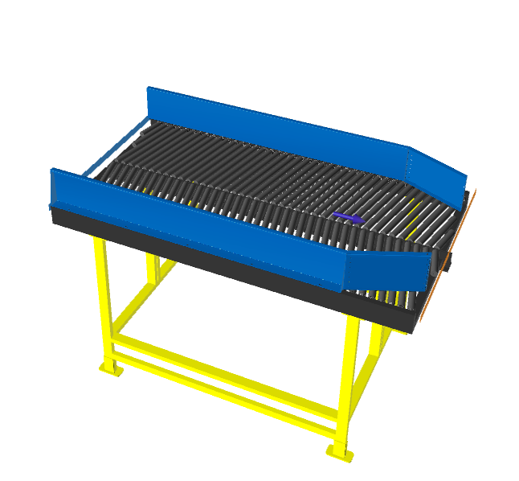
Centre Aligner

Side Barcode Scanners
System is integrated with automated inline side barcode scanning system capable for scanning 1D barcodes with high accuracy.
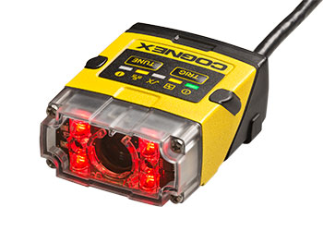
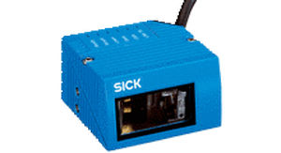

Specification | UOM | Remark
Manufacturer Name | Name | Cognex/Sick
Barcode Type | Type | 1D
Location | Side | Left
Orientation | Type | Omnidirectional
Color of bars | Color | Black
Under Foil | yes/no | No

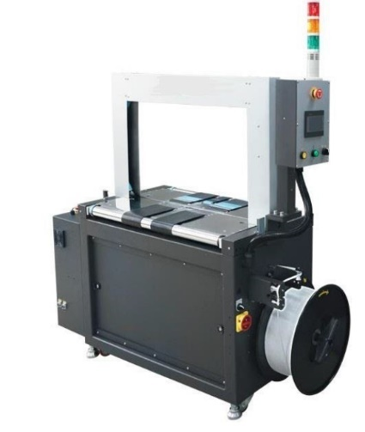

Strapping Machine

Specification | UOM | Remark
Manufacturer Name | Name | Ferag/ Signode
Speed | Boxes Per Minute | 17
Strap width | mm | 5
Throughput | BPH | 1000
Tension range for 5mm strap | Kg | 3 to 30
Motor | Type | Servo Motor
Sealing method | Type | Heating Element
Table height | mm | 805
Power consumption | KW | 1.2

Swivel Wheel Sorting Unit – Falcon
Falcon’s Swivel wheel divert is used in system for the smooth transfer of products.
Some Salient Features of Falcon’s Swivel Wheel Divert:
- Low Noise
- Maximum uptime.
- Electric based rotation of wheels.
- Minimal maintenance
- High safety standards.
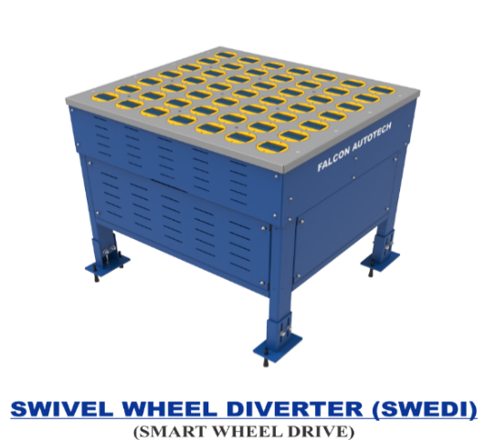

Specification | UOM | Remark
Manufacturer Name | Name | Falcon Autotech
Type - Equipment | Type | Merge/Sorting
Type - Operation | Type | Sorting
Mechanism for Swivel | Type | Electric servo motor
Roller drive | kW | Powered smart wheel
Roller pitch (L x W) | Type | 110 x 120
No. of divert sections | Yes/No | 1 or 2
Max. product weight (kg/m2) | kg/m2 | 25
Throughput | PPH | 2000
Type of Mounts | Type | Fixed Heights Legs with Grouting Provisions

Proposed System Technical Details/BOM

Mechanical equipment
Pos. | Qty. | Description | Value
1 | 1 | Infeed System  - Accumulation Roller Conveyor | ~ 15 metres (01 Modules)
2 | 1 | SWEDI Sorter  - Powered Roller Conveyor  - Accumulation Conveyor  - Gravity Roller Conveyor  - 30 deg turns  - 90 deg turns  - Angle Merge  - SWEDI Unit  - Side Scanner  - Scanning Conveyor  - Top Barcode scanner  - Strapping System | ~11.3 meters (03 modules)  ~10 meters (06 modules)  ~10.5 meters (03 modules)  03 Nos  03 Nos  03 Nos  03 Nos  02 Nos  01 Nos  01 Nos  02 Nos

Electrical Equipment
Electricals
1 | 1 | Consists of  Main Power Distribution panel  Main Control Panel  Network Switches  Field Cabling | Included

Control System
Components
1 | 1 | Consists of  Siemen’s/Omron PLC based Control System with Industrial Switch | 1 Nos.  As per requirement

High Availability Server Specifications
S.no | Make | Model | Description | Qty
1 | Synology | 723+ | Synology_storage_DS723+ 2.6 GHz AMD Ryzen R1600 Dual-Core, 2 x Gigabit Ethernet Ports,  2GB ECC DDR4 RAM, 2 x 3.5/2.5" Bays | M.2 2280 Slots E10G22-2GB ECC DDR4 RAM, 2 x 3.5/2.5" Bays | 2 x M.2 2280 Slots E10G22-T1-Mini 10GbE RJ-45 network upgrade module for compact Synology servers | 2
2 | Dell | T550 | Dell T550 8 Bay 3.5 LFF Server,Intel 4316 Processor 20 Core, Base 2.30GHz, Turbo 3.40GHz,Dell 32GB RAM 2Rx4 DDR4 3200MHz RDIMM*8,Dell 1.2TB HDD 10K RPM SAS 12Gbps 512n 2.5,Broadcom 5720 Dual Port 1GB Network Card Onboard LOM,Dell Broadcom 5720 Dual Port 1G Network Card,PERC H755 8GB NV Cache Raid Controller,Trusted Platform Module 2.0 V3,OpenManage Enterprise Advanced,iDRAC9, Enterprise 15G,Dell 800W Power Supply for 15G Servers*2,3 YR ProSupport 4Hr and Mission Critical | 2
3 | Dell | T150 | PowerEdge T150 Intel Xeon E-2314 Processor 2.8GHz 8M Cache,4C/4T,Turbo,65W,TPM 4 DIMMS 4 x 32GB UDIMM Upto 4, 3.5" SATA Drives 2TB Hard Drive SATA 6Gbps Enterprise 7.2K 512n 3.5in Cabled Onboard* +512 GB SSD, Dual Gigabit ethernet onboard + 1 dedicated management port Single Power Supply,Extra LAN Port 300W iDRAC Basic 3YR Pro Support Next Business Day Onsite | 1
4 | Microsoft | Server 2019 | Windows Server Standard 2019 | 3
5 | Dell | 19.5" Monitor with HDMI And VGA Port | Monitor | 1
6 | Aten | KVM SWITCH (4 PORT) | KVM Switch | 1
7 | Dell | Dell | Mouse wired | 1
8 | Dell | Dell | Keyboard wired | 1
9 | Dlink | Dlink | Lan Cable | 10
10 | Standard | Standard | Power Cable | 8
11 | Standard | Standard | VGA Cable | 1
12 | APW | APW | 42 AC Server Rack | 1
13 | Netgear | GS724T | Netgear 24 Port Giga Switch | 2
14 | Standard | Standard | 2 TB SSD Micron | 4
15 | Microteck | UPS | 1 KVA | 4
16 | Cadyce | Cadyce | DP TO VGA CONVERTER CADYCE BRAND | 1

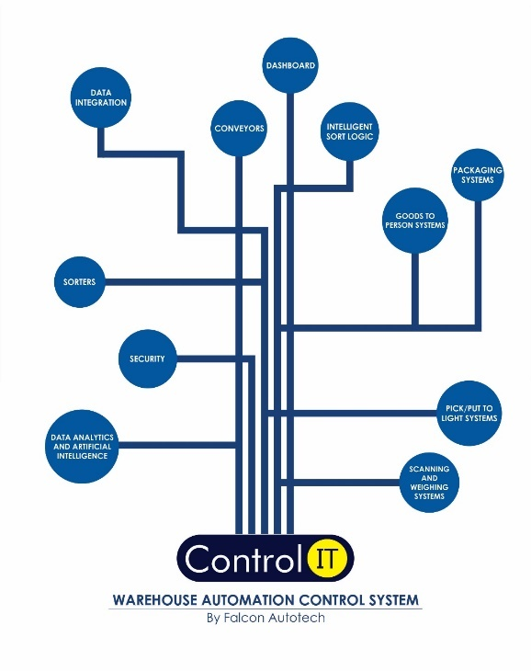
Falcon’s WCS CONTROLIT

Key Values
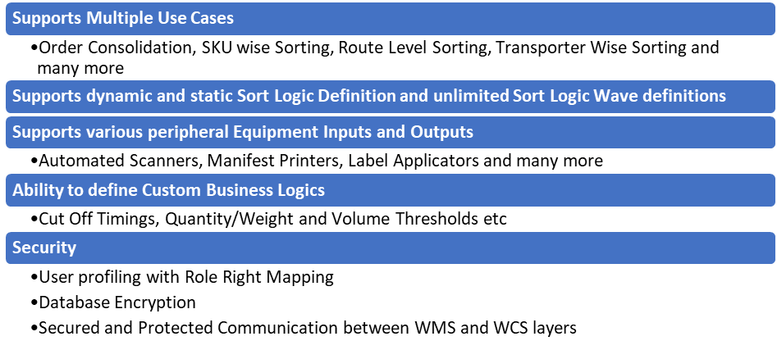
Supported Protocols
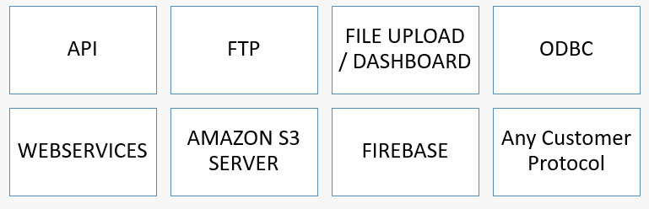

Key Component Makes
Component | Make
PLC & RIO | Siemens/Omron
VFD | Siemens/Omron/Lenze/AB
Ethernet switch | Siemens/Phoenix Contact
SMPS | Omron/Selec/Meanwell
Line chokes | EMIS/GURU NANAK ELE.
Slim relays | Phoenix contact
Terminals | Wago
Phase failure relay | Selec
Tower lamp + Hooter | Leuze
Utility switch & socket | Anchor
Fan/Air conditioner | Rexnord
Switchgear | Schneider
Main load break switch (CP) | Schneider
Geared Motors | SEW
MDR | Pulse
Cameras | Cognex

Safety

Push Buttons
Emergency Push Buttons will be provided at all the points of human interaction on the system.
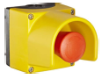

Safety Netting, barricading, Bollards, toe guards or any such safety requirements shall be in Festo Scope. Any other safety requirements requested by Festo will be on chargeable basis.

Program Organisation
Note- Approx. 90-120 days required to handover the system from the date of formal confirmation.

Program Management
For this program, proposed approach covers the following aspects:
- Creation and monitoring of the project plan.
- Communication with FESTO
- Scheduling of the resource management.
- Management of the risks and opportunities.
- Management of the list of anomalies or reservations.

Commercial Terms

Price Sheet
Sr. No | Component | Set | UOM | Total(INR)
1 | Conveyors | 1 | Set | ₹ 1,42,72,286
2 | Swedi Sorter | 1 | Set | ₹ 29,69,989
3 | Destinations | 1 | Set | ₹ 1,14,400
4 | Software Packages | 1 | Set | ₹ 2,00,000
5 | Installation & Commissioning | 1 | Set | ₹ 6,94,267
6 | Packaging & Forwarding | 1 | Set | ₹ 2,60,350
7 | Project Management and Engineering Charges | 1 | Set | ₹ 3,70,226
Grand Total |  |  |  | ₹ 1,88,81,518

The Total Price is to be understood
- Ex Works – Greater Noida, India
- Freight charges shall be extra at actual
- GST will be charged extra @ 18%
- Including Packing and Forwarding
- Duty unpaid
- Installation and Commissioning: included
- Price is valid for 60 days from the date of proposal
Our Price does not include taxes, and duties, import duties, charges, fees etc. charged by authorities outside India for deliveries and services. Same shall be borne & paid by Festo itself.
*Material Unloading & Laydown area is in customer scope

Payment Terms
The Supplier Quotation is based on the following payment schedule:
Stage 1: 50% Advance along with PO.
Stage 2: 40% along with 100% Taxes prior to dispatch.
Stage 3: 10% After Installation and commissioning within 7 Days.

Warranty Period
Falcons offered System comes with a standard warranty of 1 year (Starts from the date of beneficiary use) and post completion of warranty, customer can opt for Extended warranty. Warranty covers the following support:
- 24 X 7 Telephonic, Email and Remote Service Support when required
- Regular Software updates and Bug Fixes.
- Supply of Mechanical and Electrical components in case of failure (excluding damages as mentioned in Exclusion Clause)
The warranty does not apply to replacement or repair of:
- Normal wear and tear.
- Consumables.
- Faulty articles continued:
  - Failure to comply with the manufacturer's recommendations (logistics documentation, Technical Information Note, retrofit document) and the rules of the trade.
  - Negligence or abnormal use of equipment.
  - Anomalies produced by an environment of use, storage or transport that does not comply with the specifications or recommendations of Falcon: packaging, temperature, hygrometry, sector, insulation, etc.
  - A defect due to a cause external to the supplies and services of Falcon.
- Equipment other than that supplied by Falcon.
- Items that can be repaired exclusively by Falcon that have been repaired or attempted repairs other than those carried out by Falcon.
- Items that fail due to normal wear and tear of one or more of its components or whose tamper-evident seals (varnish, strip, etc.) have been broken or whose serial numbers have been removed or modified.
- Items damaged during transport to Falcon due to the use of unsuitable packaging.

Exclusions
The scope of supply includes all parts which are defined in the Supplier’s quotation.

All other parts which are not defined in the Supplier’s quotation do not belong to the Supplier’s scope of supply and are excluded. The following parts are also excluded:

- HAA Server
- Packing Table
- Building infrastructure; building structure, doors, fire exits, levelling devices, building extinguisher and fire alarm system, building heating and lighting system.
- Electrical power supply and wiring to the main control cabinets
- UPS for Controls and Drives
- Electrical Power for Installation
- Network Cabling up to the Main Server Rack
- Intermediate wiring to parts which are to be supplied by the Purchaser/others
- Emergency/Uninterruptable power supply
- Fire-alarm and fire protection devices
- Traffic and route markings
- Laydown Area
- Ram protection devices
- Cat walks, bridges, maintenance aisles and platforms- If not specified
- Assembly tools like forklifts and hoisting machines
- All kind of network incl. Local Area Network (LAN/WLAN), exceeding the scope described in Scope of Supply
- Any Kind of Civil work
- Any adjustment of the Supplier’s scope of supply to local rules and regulations
- X-Ray machines
- Roller cages/ Pallets
- Simulation and 3D animation of the sorter system
- Interface with other equipment not specified in this offer.
- Provision of facilities for the control room (furniture, air conditioning, heating, etc.).
- The supply and installation of fencing around the different corridors.
- Any item specifically indicated as not forming part of the subject matter of the Seller's supply in the offer documentation.

